**Task 1: load this to your local database and make api to fetch the data based on each stock**

Used postgre as Database  
step 1: made column header name as that of .csv file given in pgadmin 4   
step 2: imported the csv file in the pgadmin for the table name “stocks” (tried using python but CSV was imported, no data wasnot seen on the pgadmin.)

Step 3: using flask and SQLAlchemy extensions created a simple api  
Step 4 : while creating api

* First connected to the postgresql using SQLALCHEMY_DATABASE_URI 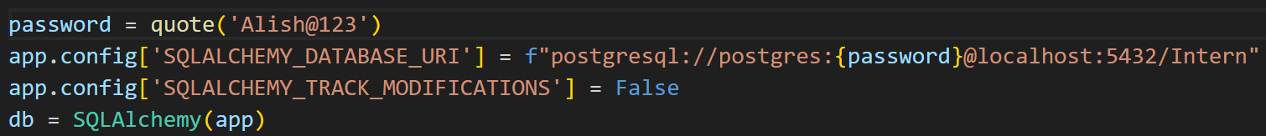
* Then created a db.model for all the listed stock names

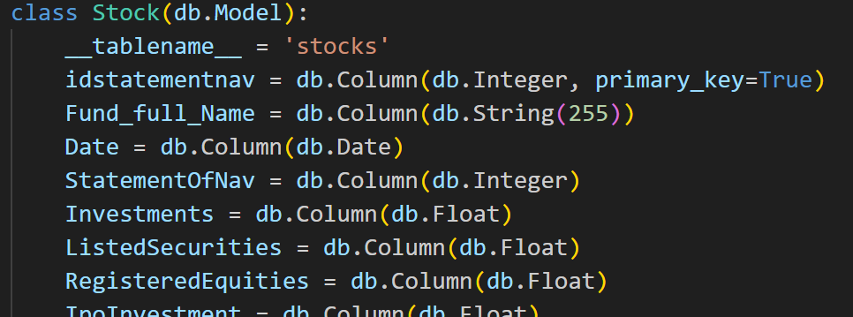

Using get method to retrieve data from the db. we are using ticker to retrieve data rather than stock name. 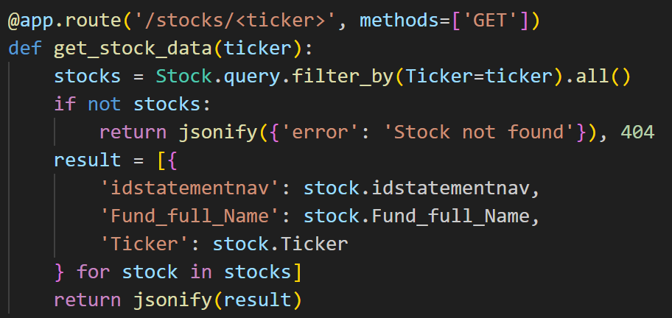

Then on browser checking the api with [http://127.0.0.1:5000/stocks/<ticker](http://127.0.0.1:5000/stocks/%3cticker)>